Created: July 2022
Last Updated: July 2022
SPECIAL IMMIGRANT JUVENILE STATUS MANUAL

- What is SIJS?

Special Immigrant Juvenile Status (SIJS) is a unique status for children present in the United States in need of protection of a juvenile court because the child has been abused, abandoned, or neglected by one or both parents. If SIJ classification is granted, the child may qualify for lawful permanent residency (also known as getting a Green Card).

- Criteria to be eligible for SIJS

  - Be under 21 years of age
  - Be currently living in the United States.
  - Be unmarried. This means you either (i) have never been married or (ii) were previously married, but the marriage ended in annulment, divorce, or death.
  - Have a valid juvenile court order issued by a state court in the United States which finds that:
    - They are dependent on the court, or in the custody of a state agency or department or an individual or entity appointed by the court;
    - They cannot be reunified with one or both of your parents because of ANY of the following: Abuse, Abandonment, Neglect or A similar basis under state law;
    - AND It is not in their best interests to return to their or their parents country of nationality or last habitual residence.
  - The Secretary of Homeland Security consents to the grant of SIJ status

- Applying for SIJS

  - STEP 1 – FAMILY STATE COURT ORDER

The child must engage in a proceeding in the state juvenile court in the county where she resides. In New York, this court is most commonly the Family Court. In Family Court, the child requests that a judge appoint a guardian or custodian for her. This underlying guardianship or custody petition provides the Court with the jurisdiction necessary to simultaneously issue a “Special Findings Order” that declares the child’s factual eligibility for SIJS (they are under 21, unmarried, etc.).

- CUSTODY

- Who can be a custodian?

A custodian can be appointed for a child until the child’s 18th birthday. Absent a court order, both biological parents have equal rights to the legal and physical custody of their child.

Anyone who has a role in the life of a juvenile can petition to be their custodian, note that under New York State case law, “extraordinary circumstances” must exist for a non-biological parent to be appointed as the child’s custodian (see Matter of Bennett vs. Jeffreys, 40 N.Y.S. 2d 543 (Ct. of App. 1976)).

The custodial parent will be responsible for the housing, education, financial support, and general well-being of the child. The court will examine what is in the best interest of the child in determining custody. Custodial parents do not have to have lawful immigration status.

- What to file?
- General Form 17: Petition - Custody, Visitation (Form GF-29 if applicable)
- Copy of Birth Certificate and Affidavit of Translation

- Where to file?

The petition must be filed in the Family Court of the county in which the child has been living for the past six months pursuant to the Uniform Child Custody Jurisdiction and Enforcement Act (N.Y. DOM. LAW § 75).

In some counties, the petitioner (the proposed custodian) must submit the custody petition herself—an agent cannot submit it on her behalf.

- GUARDIANSHIP

- Who can be a guardian?

A guardian can be appointed for a child until the child’s 21st birthday.

- Any person over 18 years old may be given guardianship.
Surrogates Court Procedure Act § 1703
- “Any person” includes a biological parent. Matter of Marisol N.H., 115 A.D.3d 185 (2d Dep’t 2014)
- Appointment must be in the “best interest” of the child
- Guardian not required to have any immigration status
- Preference of child > 14, Consent of child > 18

A guardian should safeguard the child’s physical and emotional well-being. Guardians have decision-making authority and legal responsibility for the child. This allows the guardian to secure medical treatment for the child, enroll her in school, obtain a passport for her, etc. A guardian is not financially responsible for the child.

- What to file?

- Form GF-29: Notice of Appearance
- Form 6-1 or Form 6-1-a, Petition for Guardianship of the Person
- Form 6-2, Oath and Designation for Service of Process Form
- Form 6-3, Consent of Person Over 18/Preference of Minor Over 14
- Form OCFS-3909 Request for Information (address history)
- Copy of birth certificate and affidavit of translation
- Affidavit of the Minor (if appropriate)
- Affidavit of the Guardian (if appropriate)

- Where to file?

The petition must be filed in the New York State Family Court with jurisdiction over your client’s place of residence, meaning in the county where your client has been living for the past six months, pursuant to the Uniform Child Custody Jurisdiction and Enforcement Act (N.Y. Dom. Law § 75)

In guardianship cases, court required to obtain record of indicated reports of child abuse and neglect from Office of Children and Family Services (OCFS). SCPA § 1706(2). Court may order fingerprinting of family for criminal background check. Court can order home investigation (“COI”).

- What is needed to support a Motion for Special Findings?

- Notice of Motion
- Attorney Affirmation
- Memorandum of Law in Support of Motion
- Affidavit of the Minor
- Other documents in support of the motion (death certificate of parent(s), if any; etc.)
- Proposed Special Findings Order (Form GF-42, available online)
  - USCIS requires that factual information regarding the specific case as well as the state
- law upon which the findings are based be included in the order.
- Affidavit of Service of Motion (May be waived if there is abandonment (SCPA § 1705))

- Timelines
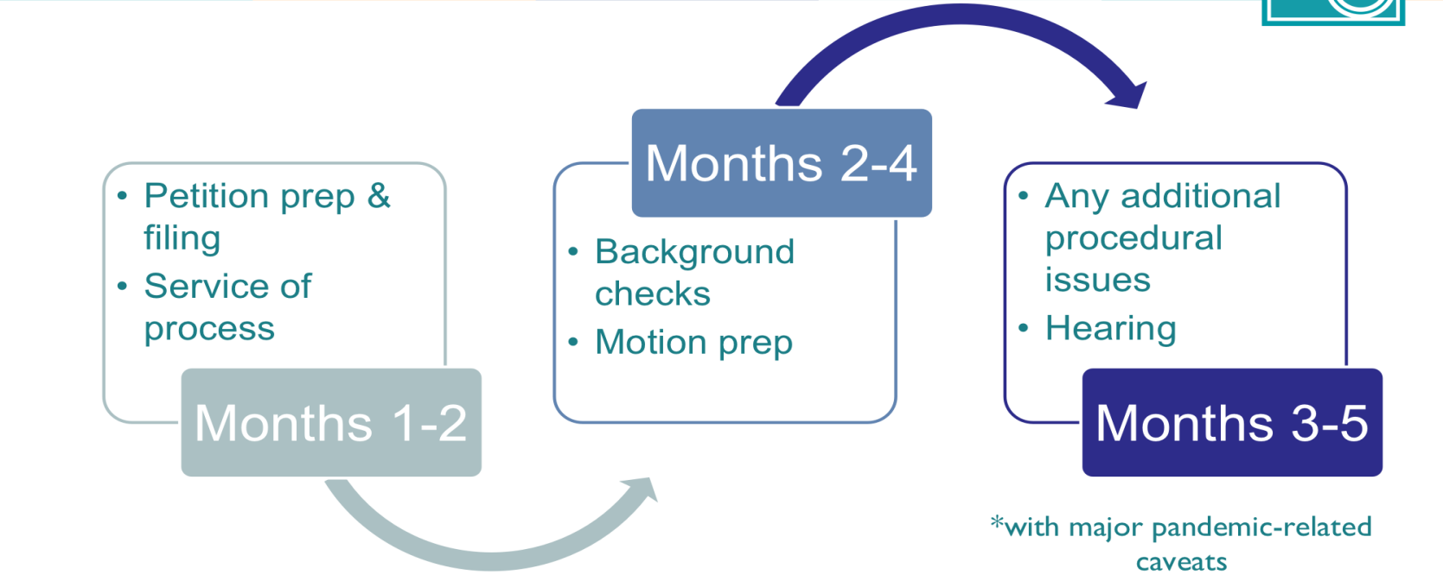
  - STEP 2 – USCIS

- How to Petition for SIJ Classification (Form I-360)

To petition for SIJ classification, you must file the following forms and supporting documentation with USCIS: (must receive the SIJS petition before the child turns 21 years)
- Form I-360, Petition for Amerasian, Widow(er), or Special Immigrant
- Cover Letter
- Copy of the Special Findings Order
- Copy of the Letter of Guardianship or Custody order
- Evidence of your age. You must submit one of the following (also submit a certified English translation, if applicable):
  - Birth certificate;
  - Passport;
  - Official identity document issued by a foreign government, such as a cartilla or a cedula; or
  - Other documents that satisfactorily establish your age.
- Written consent (PDF) from the U.S. Department of Health and Human Services (HHS) if you are in HHS custody and the juvenile court order also changes your custody status or placement.
- Form G-28, Notice of Entry of Appearance as Attorney or Accredited Representative
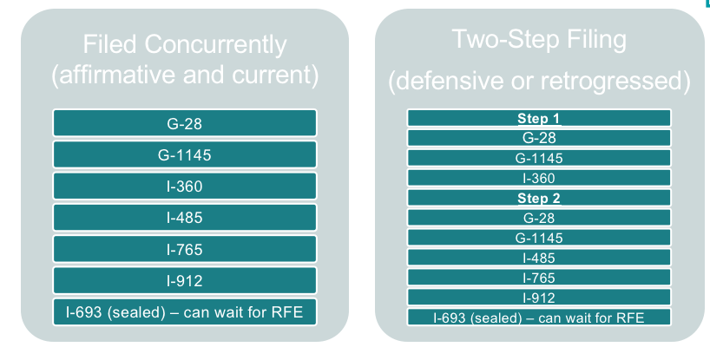

- Where to file?

As of October 2021, Form I-360, Petition for Special Immigrant Juvenile Status, should be mailed to:
For USPS: USCIS Attn: AOS P.O. Box 805887 Chicago, IL 60680-4120
For Express Mail or Courier Deliveries (FedEx, UPS) (*recommended*): USCIS Attn: AOS (Box 805887) 131 South Dearborn 3rd Floor Chicago, IL 60603-5517

  - STEP 3 – ADJUSTMENT OF STATUS

USCIS: I-485 Application to Adjust Status Once your client’s priority date is current, and assuming she is eligible to adjust status, you should file an I-485, Application to Adjust Status, with USCIS. Form I-485, Application to Adjust Status, is the important step where your client applies for full legal permanent resident status (i.e. her “green card”).

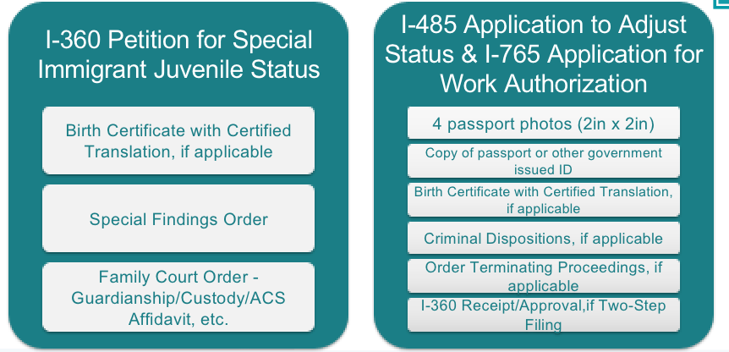

- What to file?

- Form I-485, Application for Adjustment of Status
- Form I-765, Application for Employment authorization
- Four passport-style photos
- Copy of birth certificate or other proof of age and identity with certified English translations
- Filing Fee or Form I-912, Application for Fee Waiver
- In some cases, Form I-693, Medical Exam and Supplemental Exam in a Sealed Envelope

Appendix A – New York Family Court Forms: Guardianship
These forms are from the NY Family Court. They can be found on the NY Courts’ website directly:http://www.nycourts.gov/courts/nyc/family/index.shtml

Form 6-1, Petition for Appointment of Guardian of a Person:
https://www.nycourts.gov/LegacyPDFS/FORMS/familycourt/pdfs/6-1.pdf

Form 6-1(a), Petition by Person Over 14 for Appointment of Guardian of a Person:
https://www.nycourts.gov/LegacyPDFS/FORMS/familycourt/pdfs/6-1-a.pdf

Form 6-2: Oath and Designation for Service of Process:
https://www.nycourts.gov/LegacyPDFS/FORMS/familycourt/pdfs/6-2.pdf

Form 6-3: Consent of Person Over 18 and Preference of Person Over 14 Regarding Appointment
of Guardian: https://www.nycourts.gov/LegacyPDFS/FORMS/familycourt/pdfs/6-3.pdf

Form 6-4: Waiver of Process, Renunciation or Consent to Letters of Guardianship:
https://www.nycourts.gov/LegacyPDFS/FORMS/familycourt/pdfs/6-4.pdf

FormOCFS-3909: https://www.nycourts.gov/LegacyPDFS/FORMS/surrogates/pdfs/OCFS3909.pdf24

GF-29, Notice of Appearance: http://ww2.nycourts.gov/forms/familycourt/general.shtml

Form GF-42 Special Findings Order:
http://ww2.nycourts.gov/forms/familycourt/custodyvisitation.shtml

Appendix B – New York Family Court Forms: Custody

General Form 17, Petition for Custody:
https://www.nycourts.gov/LegacyPDFS/FORMS/familycourt/pdfs/GF-17.pdf

GF-29, Notice of Appearance: http://ww2.nycourts.gov/forms/familycourt/general.shtml

Form GF-42 Special Findings Order:
http://ww2.nycourts.gov/forms/familycourt/custodyvisitation.shtml

Appendix C – Service on Respondents
Personal Service
The most common form of service is direct in-person service, many times accomplished by a family member or acquaintance of the child. The “process server” must be over age 18 or older and not a party to the proceedings. This person should physically take the documents and deliver them directly to the parent(s) in the home country.
The process server must complete and Affidavit of Personal Service in their native language, describing the date and location that service was effectuated.
You may also consider contacting organizations that specialize in cross-border collaborations and support, including realizing personal service in the country of origin. Justice in Motion or the Cyrus R.Vance Center for International Justice are two such organizations, that provide assistance to U.S. attorneys at a low cost or no cost at all.

Mail Service
Another common form of service is via international carriers such as DHL or Federal Express.
Additionally, judges are becoming more comfortable with facsimile and email as forms of service.
In some parts of El Salvador and Guatemala, USPS and Fed Ex will not deliver documents because it is too dangerous for the mail carriers or the location of the respondents is too remote.

Service in Conformity with the Hague Convention
If a country is a state party to the Hague Convention on International Service, then service must comply with the Hague Convention. The Hague Convention is incorporated in Federal Rule of Civil Procedure 4(f). The Convention provides for three methods of service: 1) by a Central Authority of the individual country; 2) by International Registered Mail; or 3) through direct service through an agent of the receiving country. It is important to research the individual country where service will occur to determine, a) whether that country is even a party to the Hague Convention, and b) if that country has “reserved” any part of the Convention. If it has “reserved” a particular form of service, then that form of service would not be acceptable.

To determine if a country is a party to the Hague Convention on International Service, please visit https://www.hcch.net/en/instruments/conventions/status-table/?cid=17

You may also visit https://www.hcch.net/en/instruments/conventions/specialised-sections/service if you wish to obtain additional information on the Hague Convention on International Service, including the text of the Convention.
Please note: Guatemala, El Salvador, Honduras, and Ecuador are NOT parties to this Convention, which means that service per the CPLR should control. Mexico is a state party to the Convention.However, there is confusion amongst Family Court judges as to when the Hague Convention applies, and what it means for service.

Service through the Central Authority of the Individual Country
To effectuate this type of service the attorney must complete form USM-94 and attach two copies of the document one wishes to serve in the language of the country. The attorney may choose to provide “formal” service – which is sending the documents to the Central Authority, usually the Ministry of Justice, who will then send those documents to the individual.

The attorney may also choose to provide “informal service” whereby the documents are sent directly to the party. This informal service must be consented to as per Rule 4(d) of FRCP.

Service by Internationally Registered Mail
This service may be effectuated by simply sending the documents in the registered mail. This method of service, however, is somewhat contended and requires research on whether the individual country “reserved.” If, in fact they did reserve, service should not be effectuated in this manner. Service through a State Agent An attorney may serve an individual through an agent of the foreign state. The individuals must be “judicial officers, officers, officials or other component persons of the State of Destination.” See https://www.hcch.net/en/instruments/conventions/full-text/?cid=17
(Article 10 of the Convention).

Waiver of Service and Consent to Guardianship/Custody Some judges accept Form 6-4 “waiver and consent,” signed and notarized by the respondent parent, in lieu of proof that the summons and petition was personally served upon the parent. The respondent parent could, if they choose, sign form 6-4 in their native language. The form states that they consent to the form of relief being sought (guardianship or custody), and that they do not require future service of motions, subsequent petitions, judges’ orders, etc.

Appendix D – Immigration Forms

All forms are available online. We recommend downloading the forms from the USCIS website every time you need to fill out a form. USCIS often changes the form edition without notice and will not accept previous editions.

Form G-28, Notice of Entry of Appearance as an Attorney: http://www.uscis.gov/g-28

Form I-360, Petition for Special Immigrant Juvenile Status: http://www.uscis.gov/i-360

Form I-485, Application for Adjustment of Status: http://www.uscis.gov/i-485

Form I-765, Application for Employment Authorization: http://www.uscis.gov/i-765

Form G-325A, Biographic Information: http://www.uscis.gov/g-325a

Form I-601, Application for Waiver of Grounds of Inadmissibility: http://www.uscis.gov/i-601

Fee Schedule: http://www.uscis.gov/fees

Form I-912, Application for Fee Waiver: https://www.uscis.gov/i-912

Appendix E – Inadmissibility Issues

Certain grounds of inadmissibility are inapplicable or statutorily waived for youth who have been granted Special Immigrant Juvenile Status.

The following are grounds of inadmissibility automatically waived for SIJS applicants. Your client does not need a waiver if she is charged with or has done any of the following:
• Public Charge (INA § 212(a)(4))
• Worked without Authorization (INA § 212(a)(5)(A))
• Entered Illegally or has incurred Immigration Violations (INA § 212(a)(6)(A))
• Material Misrepresentation of Fact (INA §212(a)(6)(C))
• Stowaway or Smuggler (INA §212(a)(6)(D))
• Entered without Proper Documentation (INA § 212(a)(7)(A))
• Unlawful Presence (INA § 212(a)(9)(B))

Other grounds are not automatically waived and require further research and expertise. Though not automatically waived, people with SIJS status who are inadmissible due to the following violations may be eligible for a waiver of inadmissibility.

Waivers of inadmissibility may be possible for:
§ Health related grounds (INA § 212(a)(1))
o 212(g) waiver
§ Certain crimes (INA § 212(a)(2))
o Be particularly aware of controlled substances and firearms offenses. (INA §212(a)(2)) o The Attorney General can waive criminal offenses for humanitarian purposes.
o There is also a waiver if the conviction is for one possession of marijuana less than 30 grams.
§ Having been previously removed (INA § 212(a)(9)(A))
§ Having previous immigration violations (INA § 212(a)(9)(C))

No Waivers Available for:
§ Security related grounds (INA § 212(a)(3))
o There is no waiver for this violation, except for the 212(d)(3) waiver. To qualify for this waiver, the juvenile must have entered with a non-immigrant visa.
§ Draft evaders (INA § 212(a)(8)(B))
§ 212(a)(2)(A), (B) and (C) (except for a single instance of simple possession of 30 grams or less of marijuana) and INA § 212(a)(3)(A), (B), (C) and (E).

Appendix F – Contact Information

Executive Office for Immigration Review (EOIR)
To check an A# and learn the status of the next hearing you can use EOIR’s automated phone system by dialing 1-800- 898-7180.

New York—26 Federal Plaza
Phone Number: 917-454-1040
Address: 26 Federal Plaza, Room 1237, New York, NY 10278.

New York—290 Broadway
Phone Number: 212-240-4900 Address: Ted Weiss Federal Building, 290 Broadway, Suite 2900, New York, NY 10007

New York—Varick Street
Phone number: 646-638-5766 Address: 201 Varick Street, 5th Floor, Room 507, New York, NY 10014

New York City Family Courts
Bronx
Phone Number: 718-618-2098 Address: 900 Sheridan Ave., Bronx, NY 10451
New York (Manhattan)
Phone Number: 646-386-5223 Address: 60 Lafayette St., New York, NY 10013.
Kings (Brooklyn)
Phone Number: 347-401-9610 Address: 330 Jay Street, Brooklyn, NY 11201.
Queens
Phone Number: 718-298-0197 Address: 151-20 Jamaica Ave., Jamaica, NY 11432.

Richmond (Staten Island)
Phone Number: 718-675-8800 Address: 100 Richmond Terrace, Staten Island, NY 10301.
Long Island Family Courts:
Nassau
Phone Number: 516-493-4000 Address: 1200 Old Country Road, Westbury, NY 11590
Suffolk Central Islip
Phone Number: 631-740-3800 Address: 400 Carleton Ave., Central Islip, NY 11722
Riverhead
Phone Number: 631-852-3905/6 Address: 210 Center Drive, 2nd Floor, Riverhead, NY 11901
Westchester County Family Courts
White Plains
Phone Number: 914-824-5500 Address: 111 Dr. Martin Luther King Jr. Blvd., White Plains, NY 10601
Yonkers
Phone Number: 914-831-6555 Address: 131 Warburton Avenue, 3rd Floor, Yonkers, NY 10701
New Rochelle
Phone Number: 914-831-6590 Address: 26 Garden Street, New Rochelle, NY 10881
Rockland County Family Court
Phone Number: 845-483-8210 Address: 1 South Main Street, Suite 300, New City, NY 10956
Putnam County Family Court
Phone Number: 845-208-7800 Address: 20 County Center, Carmel, NY 10512
Orange County Family Court
Phone Number: 845-476-3520 Address: 285 Main Street, Goshen, NY 10924
Dutchess County Family Court
Phone Number: 845-431-1850 Address: 50 Market Street, Poughkeepsie, NY 12601

For updated information on New York State Courts, please visit: http://www.nycourts.gov/courts/nyc/family/infobycounty.shtml

USCIS Information National Customer Service Center: 1-800-375-5283

USCIS Civil Surgeon Locator
Young people who are applying for adjustment of status through SIJS are required to have a medical examination by a civil surgeon. A civil surgeon is a doctor who has been designated by USCIS to conduct this type of medical examination. To locate a civil surgeon, please visit: https://my.uscis.gov/findadoctor

USCIS Case Status Check
If your client has a pending case at USCIS, use their Receipt Notice to look up their case status using this website: https://egov.uscis.gov/casestatus/landing.do

*The website is not always up to date. For more accurate information call the USCIS hotline.

Address Changes: All non-citizens must file a Change of Address form with immigration agencies (EOIR, USCIS, ICE) within 10 days of moving. What type of form and where to file depends on the posture of the case:
• If a non-citizen has an open case in immigration court, she must fill out an EOIR-33 Change of Address http://www.justice.gov/eoir/eoirforms/eoir33/ICadr33.htm by mailing one copy to the court, and one copy to ICE.
• If she has a case pending with USCIS, she can file an AR-11 online at https://egov.uscis.gov/coa/displayCOAForm.do
• If she has both an open immigration court case and a case pending with USCIS, both forms must be submitted. USCIS posts policy updates here: https://www.uscis.gov/policy-manual/updates

8 U.S.C. 1101(a)(27)(j); INA 101(a)(27)(j); 8 C.F.R 204.11
In the Matter of the Guardianship of Michael Lafontant, an Infant, 617 N.Y.S.2d 292 (Surrogate’s Ct., Rockland Cty. 1994); Matter of Marisol N.H., 115 A.D.3d 185 (N.Y. App. Div. 2d Dep’t 2014)

